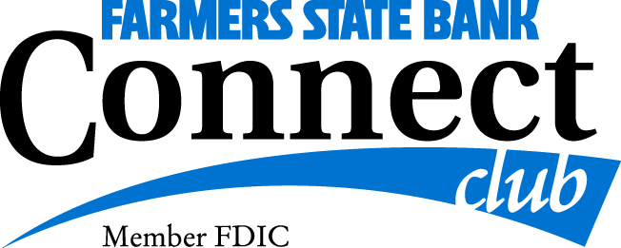

Additional Information Form
Discovering Poland
August 6 – 18, 2021

Name: _______________________________ Member of Connect Club: Yes _____ No_____

Rooming With: _________________________________________________________________

Special Airline Requests (Seating, Wheel Chair Assistance, etc…): ______________________________________________________________________________

______________________________________________________________________________

Special Assistance Needed (Wheelchair, hotel preferences, etc…): ______________________________________________________________________________

______________________________________________________________________________

Dietary Restrictions: ____________________________________________________________

Collette Loyalty: Yes_____ No_____

Special occasion during the tour: _________________________________________________
Passport: Please take a moment to locate your passport and check the expiration date. The expiration date needs to be valid for 6 months after the last day of travel. If your passport expires prior to 2/18/2022, you will need to renew. Please mail or stop by my office with a copy of your Passport Picture Page

Comments: ____________________________________________________________________

______________________________________________________________________________

______________________________________________________________________________

____________________________________________________ ______________________
Signature Date

