**Ballards Resort Fishing Trip with Gene Neighbor**

**Minnesota’s Lake of the Woods 3314 Bur Oak Rd NW Baudette MN 56623**

**Sunday July 23 to Wednesday July 26, 2023**

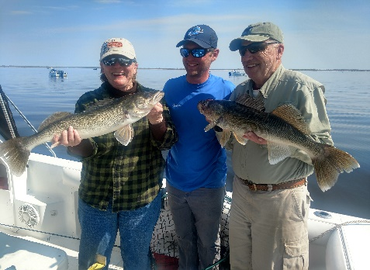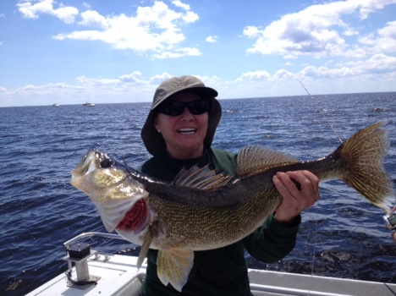

Special Rate of $1,000.00 per person

After March 31, 2023 the special rate ends and the rate increases to $1,125 per person.

**Join Gene and Jean on this exciting summer fishing trip!**

*Sunday, July 23rd:* Depart from Marion at 6:00 am, arrive at Ballard’s Resort 4:00 pm, check-in, group orientation, complimentary welcome reception, evening dinner, lodging first night.

*Monday, July 24th:* Breakfast at 7 am, guided walleye fishing (8-4), lunch on the lake, evening dinner, lodging in Cabin.

*Tuesday, July 25th:* Breakfast 7 am, guided walleye fishing. (8-4), lunch on the lake, evening dinner, lodging in Cabin.

Wednesday, July 26th: 6am breakfast, depart lodge at 7am, mid-day lunch on coach, and arrive in Marion at 5pm.

**Additional Information**

Lodging in Cabins: Each unit is complete with living room, two single beds per bedroom, bathroom, TV, towels, bedding, & daily maid service. Wi-Fi in the cabins.

Guided Walleye Fishing: 27 ft. Sport crafts (guide boats), include angling equipment, bait, tackle, on-board restroom facilities, & fish processing. The boats accommodate up to six anglers, plus Coast Guard licensed guide. No Wi-Fi on the boat.

Meals: Piping hot breakfasts, shore lunches prepared for you daily and gourmet evening dinners.

Motor coach: 56 passenger deluxe model includes DVD-VCR video monitors, Wi-Fi capabilities, restroom facilities & Comfortable seating.

Bring a small cooler to pack your own lunch and beverages for the ride to Ballard’s. You can use this cooler to transport your fish back home. Bring your own beverages for the tour or purchase from the full service bar that offers a complete list of beers, liquors and non-alcoholic beverages.

MN fishing license: FSB will submit your form to Ballard’s ($37) or you can purchase online at [**www.licenses.dnr.state.mn.us**](http://www.licenses.dnr.state.mn.us).

Pricing includes: Round trip coach transportation from Marion, three nights lodging, two days guided walleye fishing, meals, rods, reels, bait, tackle, fish processing, all gratuities (fishing guides, restaurant wait staff, daily housekeeping), sales and lodging tax.

A deposit of $300 per person and your completed reservation form is due by March 31, 2023.

Final Payment is due by June 23, 2023.



**Trip Reservation Form**

**Ballard’s Resort Fishing Trip**

**Sunday July 23 to Wednesday July 26, 2023**

**One reservation form per person**

**Name (1) __________________________________ Nickname: ________________________________**

**Address: _____________________________________________________________________________________**

**Email: _____________________________________________________________________________________**

**Home Phone: __________________________________ Cell Phone: ___________________________________**

**Date of Birth: _____________________________________________________________________________________**

**Emergency Contact Name: __________________________________ Cell Phone: _____________________________**

**Roommate’s Name: _________________________________________________________________________________**

**Special Requests (dietary, accommodations, wheelchair etc…) ____________________________________________**

**__________________________________________________________________________________________________**

**Celebration During the tour: ____________________________________________________________**

**Fishing License: Have one: ____________ Purchase one from Ballard’s ($37) _____________**

**Payment Information**

$300 Deposit per person and form due by: March 31, 2023

Final Payment per person due by: June 23, 2023

$1,125.00 per person if register after March 31, 2023

Payment refundable if cancel by March 31, 2023

Please mail this form along with your payment to: FSB Connect Club - Kathy Leesekamp

1240 8th Ave Marion IA 52302

**Signature: ____________­­­­­­________________________ Signature: ______________________________**

**Date: ____________________________________ Date: ______________________________**