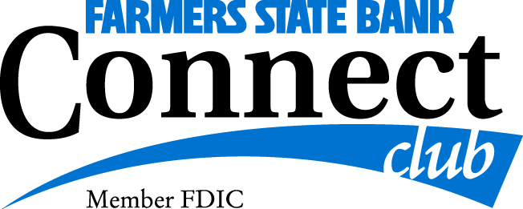
Trip Reservation Form

Ladies Outing
Monday, May 6, 2024

Name (1) __________________________________ Nickname: ________________________________

Address: _____________________________________________________________________________________

Email: _____________________________________________________________________________________

Home Phone: __________________________________ Cell Phone: ___________________________________

Date of Birth: _____________________________________________________________________________________

Emergency Contact Name: __________________________________ Cell Phone: _____________________________

Travel Partner’s Name: _______________________________________________________________________________

Special Requests (dietary, accommodations, wheelchair etc…) ____________________________________________

__________________________________________________________________________________________________

Celebration During the tour: ____________________________________________________________

Payment Information
$150.00
Reservation form and payment will be due at the time of sign-up
Deadline to sign up for this tour is April 1, 2024

Please mail this form along with your payment to: FSB Connect Club - Kathy Leesekamp, CBCD
1240 8th Ave
Marion IA 52302

Signature: ______________________________________ Date: _____________________________________

Kathy Leesekamp CBCD - -Connect Club Director (319) 294-2900

