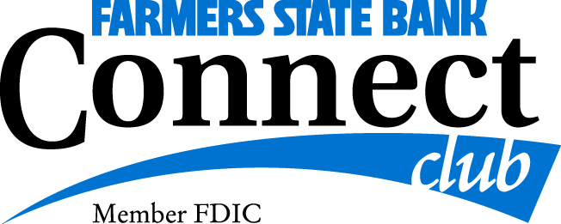
Trip Reservation Form

Ballard’s Resort Fishing Trip
August 24 – 27, 2020

Name (1) __________________________________ Nickname: ________________________________

Address: _____________________________________________________________________________________

Email: _____________________________________________________________________________________

Home Phone: __________________________________ Cell Phone: ___________________________________

Date of Birth: _____________________________________________________________________________________

Emergency Contact Name: __________________________________ Cell Phone: _____________________________

Roommate’s Name: _________________________________________________________________________________

Special Requests (dietary, accommodations, wheelchair etc…) ____________________________________________

__________________________________________________________________________________________________

Celebration During the tour: ____________________________________________________________

Fishing License: Have one: ____________ Purchase one from Ballard’s ($37) _____________

Payment Information
$200 Deposit per person and form due by: March 31, 2020
$815.00 Final Payment per person due by: July 1, 2020
$885.00 per person if register after March 31, 2020

Please mail this form along with your payment to: FSB Connect Club - Kathy Leesekamp
1240 8th Ave
Marion IA 52302

Signature: ____________________________________ Signature: ______________________________

Date: ____________________________________ Date: ______________________________

Kathy Leesekamp-Connect Club Director (319) 294-2900

