Tuesday, May 16, 2023 * 8:30 AM
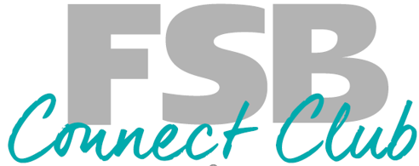
Trip Reservation Form

Ladies Outing
Tuesday May 16, 2023 at 8:30 am (Time Change)
One Form per Lady

Name (1) __________________________________ Nickname: __________________________

Address: __________________________________________________________________________
Email: __________________________________________________________________________
Home Phone: _________________________ Cell Phone: _____________________________________

With a friend or family member (name): _______________________________________________________

_____________________________________________________________________________________

Special dietary Requests: _________________________________________________________________
Payment Information
Reservation Form and $80 per person due now
Non Refundable after April 15, 2023
- Pay by Check
- Take from my account: Account Number: ________________________
- Pay with Credit Call (add information below or call me with your information
Card Number __________________________ Expiration Date: _____________________
Please mail this form and your payment to:
FSB Connect Club - Kathy Leesekamp 1240 8th Ave Marion IA 52302

Signature: ______________________________________ Date: __________________________

Signature: ______________________________________ Date: __________________________

Kathy Leesekamp, CBCD - Connect Club Director (319) 294-2900

