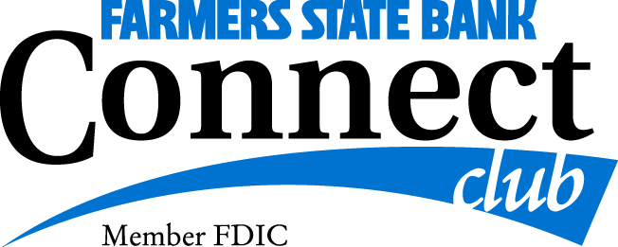
Trip Reservation Form

4 Day Mystery Tour
August 18-21, 2020

Name (1) __________________________________ Nickname: ________________________________

Address: _____________________________________________________________________________________

Email: _____________________________________________________________________________________

Home Phone: __________________________________ Cell Phone: ___________________________________

Date of Birth: _____________________________________________________________________________________

Emergency Contact Name: __________________________________ Cell Phone: _____________________________

Travel Partner’s Name: _______________________________________________________________________________

Special Requests (dietary, accommodations, wheelchair etc…) ____________________________________________

__________________________________________________________________________________________________

Celebration during the tour: ____________________________________________________________

Please check one: ______ King bed OR ______ Two Double Beds

Payment Information
$150.00 deposit and form to reserve your seat - due by June 19, 2020
Final payment due by: July 19, 2020

Single $1,089 pp _____ Double $929 pp_____ Triple $909 pp _____ Quad $899 pp_____

Please mail this form along with your payment to: FSB Connect Club - Kathy Leesekamp
1240 8th Ave
Marion IA 52302

Signature: ______________________________________ Date: _____________________________________

Kathy Leesekamp-Connect Club Director (319) 294-2900

