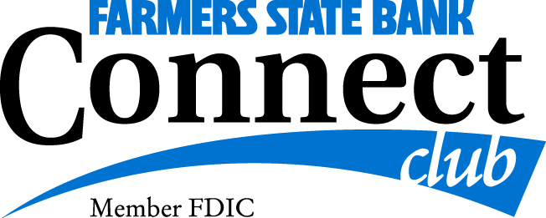
Trip Reservation Form

One Day Mystery Tour
Thursday, September 5th or Friday September 6th (circle your choice)

Name/Nickname (1)__________________________________ Name/Nickname (2):________________________________

Address: _____________________________________________________________________________________

Email: _____________________________________________________________________________________

Home Phone: __________________________________ Cell Phone: ___________________________________

Date of Birth (1):_______________________________ Date of Birth (2): ___________________________

Emergency Contact Name: __________________________________ Cell Phone: _____________________________

Travel Partner’s Name: _______________________________________________________________________________

Special Requests (dietary, accommodations, wheelchair etc…) ____________________________________________

__________________________________________________________________________________________________

Celebration During the tour: ____________________________________________________________

Payment Information
$150.00
Reservation form and payment will be due at the time of sign-up
Deadline to sign up for this tour is August 1, 2024

Please mail this form along with your payment to: FSB Connect Club - Kathy Leesekamp, CBCD
1240 8th Ave
Marion IA 52302

Signature: ______________________________________ Date: _____________________________________

Kathy Leesekamp CBCD - -Connect Club Director (319) 294-2900

