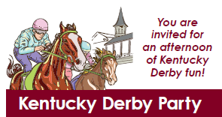

Saturday, May 6, 2023
Elmcrest Country Club 1 Zach Johnson Drive NE Cedar Rapids IA 52401
$50 per person

ITINERARY
4:30 pm Arrive and Place Bets
5:00 pm Social Hour with Hors d’oeuvres and drinks
5:57pm Post time and the greatest two minutes in sports!
6:00 pm Prizes will be awarded for…
Best dressed (Guys and Girls)
Best Hats (Guys and Girls)
1st, 2nd & 3rd Place Horse Race Winners

Kathy Leesekamp, CBCD - Connect Club Director (319) 294-2900

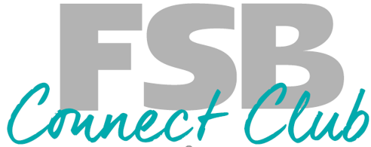
Trip Reservation Form

Kentucky Derby Party
Saturday, May 6, 2023

Name (1) __________________________________ Nickname: __________________________

Name (2) __________________________________ Nickname: __________________________

Address: __________________________________________________________________________
Email (1): __________________________________________________________________________

Email (2): __________________________________________________________________________
Cell Phone (1):_________________________ Cell Phone (2): __________________________________

Payment Information
Reservation Form and $50 per person due now
Deadline to sign up & receive full refund: April 6, 2023
- Pay by Check
- Take from my account: Account Number: ________________________
- Pay with Credit Call (add information below or call me with your information
Card Number __________________________ Expiration Date: _____________________
Please mail this form and your payment to:
FSB Connect Club - Kathy Leesekamp 1240 8th Ave Marion IA 52302

Signature: ______________________________________ Date: __________________________

Signature: ______________________________________ Date: __________________________

Kathy Leesekamp, CBCD - Connect Club Director (319) 294-2900

